# TITLE PAGE

**DATABASE MANAGEMENT MODEL FOR INTERNAL REVENUE GENERATION (CASE STUDY OF COTTAGE, GOMBI)**

**BY**

**DIWA M. FAVOUR**

**ST/CS/ND/21/104**

**DEPARTMENT OF COMPUTER SCIENCE,**

**SCHOOL OF SCIENCE AND TECHNOLOGY,**

**FEDERAL POLYTECHNIC, MUBI, ADAMAWA STATE.**

**IN PARTIAL FULFILLMENT OF THE REQUIREMENT FOR THE AWARD OF NATIONAL DIPLOMA (ND) IN COMPUTER SCIENCE.**

**SEPTEMBER, 2023**

# DECLARATION

I hereby declare that the work in this project titled **“Database Management Model for Internal Revenue Generation (Case Study of Cottage, Gombi)”** was performed by me under the supervision of Mr. A. A. Bazway. The information derived from literatures has been duly acknowledged in the text and a list of references provided. The work embodied in this project is original and had not been submitted in part or in full for any other diploma or certificate of this or any other institution.

DIWA M. FAVOUR ________________ _______________

(ST/CS/ND/21/104) Signature Date

# CERTIFICATION

This project titled **“Database Management Model for Internal Revenue Generation (Case Study of Cottage, Gombi)”** meets the regulations governing the award of National Diploma (ND) in Computer Science, Federal Polytechnic Mubi, Adamawa State

Mr. A. A. Bazway __________________

(Project Supervisor) Sign/Date

Mr. Mustapha Kassim __________________

(Head of Department) Sign/Date

Mal. Abdulrahman Saidu _________________

(External Examiner) Sign/Date

# DEDICATION

This project is dedicated to my beloved parents for their advice, encouragement and financial support towards my academic pursuit.

# ACKNOWLEDGEMENTS

I want to acknowledge Almighty God for his infinite mercy and protection throughout my academic activities. And for the understanding in achieving our academic success.

I also recognize my Supervisor Mr. A. A. Bazway who took time, despite her busy schedule to directed and guided me throughout this research work.

I also acknowledge the Head of Department Computer Science Mr. Mustapha Kassim for his moral encouragement throughout my period of study. I also acknowledge all Staff of Computer Science Department for their support and encouragement and the knowledge they’ve impacted on me throughout our studies.

I also want to appreciate our parents for their love and care and for giving me the opportunity to be trained and achieve our dreams.

Finally, I appreciate the efforts of my Uncles and aunties, for their encouragement and support throughout the course of our study and also our friends and relatives, course mates and all well-wishers. I love you all, may the Almighty God bless you abundantly, Amen.

# TABLE OF CONTENTS

TITLE PAGE i

DECLARATION ii

CERTIFICATION iii

DEDICATION iv

ACKNOWLEDGEMENTS v

TABLE OF CONTENTS vi

LIST OF FIGURES viii

LIST OF TABLES ix

ABSTRACT x

CHAPTER ONE 1

INTRODUCTION 1

1.1 Background to the Study 1

1.2 Problem Statement 2

1.3 Aim and Objectives 3

1.4 Significance of the Study 3

1.5 Scope of the Study 3

1.6 Definition of Some Operational Terms 4

CHAPTER TWO 5

LITERATURE REVIEW 5

2.1 Introduction 5

2.2 Revenue Generation Systems 5

2.3 Automation in Revenue Generation 6

2.4 Information Management System 7

2.4.1 Importance of Information Management Systems 7

2.5 Database Management System 8

CHAPTER THREE 9

SYSTEM ANALYSIS AND DESIGN 9

3.1 Introduction 9

3.2 Disadvantages of the Existing System 9

3.3 Advantages of the Proposed System 9

3.4 The Proposed Method 10

3.5 Method of Data Collection 10

3.6 System Design 10

3.6.1 Algorithm Diagram 11

3.6.2 System Architecture 12

3.6.3 Database Tables/Queries Structures 12

Table 3.1: Employees Table 12

3.6.4 Entity Relationship Diagram 13

3.6.5 Input and Output Design 13

3.7 System Requirements Specification 15

3.7.2 Software Requirements 15

3.7.3 Personnel Requirements 15

CHAPTER FOUR 16

RESULTS AND DISCUSSION 16

4.1 Introduction 16

4.2 Results 16

4.2.1 Welcome Interface 16

4.2.2 Login Interface 16

4.2.3 Add Employee Interface 17

4.2.4 Employees List interface 17

4.2.5 Dashboard Interface 18

4.3 Discussion 18

4.4 User manual 19

CHAPTER FIVE 20

SUMMARY, CONCLUSION AND RECOMMENDATIONS 20

5.1 Summary 20

5.2 Conclusion 20

5.3 Recommendations 20

5.4 Contribution to Knowledge 21

5.5 Area for Further Work 21

REFERENCES

APPENDIX A

APPENDIX B

# LIST OF FIGURES

Figure 3.1: Waterfall model- - - - - - - - - 10

Figure 3.2: Use case diagram- - - - - - - - 11

Figure 3.2: System Architecture- - - - - - - - 12

Figure 3.4: Entity Relationship Diagram- - - - - - - 13

Figure 3.5: Login interface- - - - - - - - - 13

Figure 3.6: Add Employee Form- - - - - - - - 14

Figure 3.7: Report Interface- - - - - - - - - 14

Figure 4.1: Welcome Interface- - - - - - - - 16

Figure 4.2: Login page interface- - - - - - - - 16

Figure 4.3: Add Employee Interface- - - - - - - - 17

Figure 4.4: Employee List Interface- - - - - - - - 17

Figure 4.5: Dashboard Interface- - - - - - - - 18

# LIST OF TABLES

Table 3.1: Employee - - - - - - - - - 12

Table 3.2: Admin Login - - - - - - - - 13

# ****ABSTRACT****

*Effective internal revenue generation is a fundamental element for the sustainable growth and development of organizations, particularly in the public sector. This study presents a comprehensive Database Management Model tailored to the specific needs of Cottage, Gombi, as a case study. The model focuses on enhancing the collection, management, and utilization of internal revenue data to drive informed decision-making. The study outlines a set of user-friendly interfaces, including welcoming, login, employee management, employee list, and dashboard interfaces, integrated into a coherent database management system. These interfaces not only simplify data entry and retrieval but also provide valuable insights through data visualization and analytics. Through a rigorous examination of the model's implementation in the Cottage, Gombi context, this research offers insights into the practicality and effectiveness of such systems for revenue management. The findings underscore the importance of technology-driven solutions in optimizing revenue collection and financial performance. In conclusion, this study provides a valuable reference for organizations seeking to improve their internal revenue management practices. By adopting this Database Management Model, organizations can pave the way for more efficient and transparent revenue collection processes, ultimately contributing to their financial sustainability and growth.*

# CHAPTER ONE

# INTRODUCTION

## 1.1 Background to the Study

In recent years, effective revenue generation has become a critical concern for local governments and municipalities around the world. The ability to efficiently collect and manage revenue directly impacts the provision of essential public services, infrastructure development, and overall community well-being. One key area of focus for revenue generation is the management of internal revenue, which encompasses the collection of various fees, taxes, and charges from within a specific jurisdiction. The efficient management of revenue plays a pivotal role in the sustainable development and effective governance of local municipalities. Revenue generated through various sources, such as taxes, fees, licenses, and fines, constitutes the financial backbone that supports the provision of essential public services, infrastructure projects, and community welfare programs. However, the complexities inherent in revenue collection and management pose significant challenges for many local governments, often leading to suboptimal outcomes and missed opportunities.

Traditionally, revenue collection and management in many local municipalities, including Cottage Gombi, have relied on manual, paper-based processes. These conventional methods often result in errors, data inconsistencies, delays in processing, and revenue leakages. Additionally, the lack of an integrated and centralized database system further compounds these challenges, making it difficult for local authorities to gain real-time insights into revenue trends, allocate resources effectively, and make informed decisions for sustainable development. In an increasingly digital and interconnected world, the modernization of revenue collection and management processes has become imperative. Advances in technology offer unprecedented opportunities to streamline processes, enhance data accuracy, and facilitate better decision-making. As local municipalities grapple with the complexities of revenue generation, they must embrace innovative solutions that align with best practices and harness the power of data-driven insights.

Against this backdrop, this research project seeks to address the critical need for an advanced database management model tailored to the unique context of Cottage Gombi. By leveraging cutting-edge database technologies, data integration strategies, and revenue management principles, the proposed model aims to transform Cottage Gombi's revenue collection and management landscape. Through this transformation, the municipality can overcome existing challenges, maximize revenue potential, and pave the way for sustainable development that benefits every resident and stakeholder.

Revenue generation is the nucleus and the path to modern development. This study assessed the [database management model](https://newprojecttopics.com.ng/online-database-model-for-church-record-management-a-case-study-of-qua-iboe-church-ikot-osurua-ikot-ekpene/) for internal revenue generation. The State as the second tier of government needs revenue to provide basic social amenities to the people.  It is the responsibility of the State Government to provide public good also known as collective good and execute developmental projects that would improve the standard of living of her citizenry as well as meet its recurrent expenditure. The discharge of these duties by the government requires a lot of funds. State government get fund from two sources: [Internally generated revenue and statutory](https://newprojecttopics.com.ng/internally-generated-revenue-and-infrastructural-development-in-local-government-areas-of-akwa-ibom-state-a-case-study-of-select-local-government-areas-of-akwa-ibom-state/) allocation from Federal government. Ayegba (2023), defined revenue is as a general term for all monetary receipts accruing from both tax and non-tax sources. Olaoye *et al*. (2019), also elucidate that revenue from tax and non- tax sources as well as fees, grants and contributions constitute the live wire of the State government. Taxation is the system of imposing compulsory levy on all income, goods, services and properties of individuals, partnership, trustees, executorships and company by government.  State sources for fund internally by imposing various form of tax on the tax object which could be [individuals or corporate entities](https://newprojecttopics.com.ng/the-effects-of-budgetary-control-in-achievement-of-corporate-objectives-a-study-of-champion-breweries-uyo/). The increasing cost of running government revenue has left various states governments in Nigeria with formulating strategies to improve revenue base (Wisdom *et al.,* 2020).

## 1.2 Problem Statement

Cottage Gombi, like many other local municipalities, faces challenges in optimizing its internal revenue generation processes.

1. Inefficient Manual Processes: The existing revenue collection processes in Cottage Gombi heavily rely on manual and paper-based methods, leading to errors, delays, and inefficiencies in data entry, processing, and reconciliation.
2. Lack of Data Integration: Cottage Gombi lacks a centralized and integrated database system that can consolidate revenue data from various sources, hindering the municipality's ability to track revenue streams, analyze trends, and make informed decisions.
3. Revenue Leakage and Inaccuracies: The absence of a robust system for monitoring revenue collection allows for potential leakage and inaccuracies, resulting in lost revenue opportunities and hindering the municipality's financial sustainability.
4. Limited Data-Driven Insights: The absence of data-driven insights and analytics hampers Cottage Gombi's capacity to forecast revenue, allocate resources effectively, and identify areas for revenue enhancement, ultimately affecting its ability to provide essential public services.
5. Technological Obsolescence: Cottage Gombi's reliance on outdated technologies and manual processes not only impedes efficient revenue management but also limits the municipality's adaptability to modern advancements in revenue collection, database management, and governance practices.

## 1.3 Aim and Objectives

The aim of this study is to Design and Implement a Database Management Model for Internal Revenue Generation (case study of Cottage Gombi). The specific objectives are:

1. To identify the key challenges and inefficiencies in the current revenue management system.
2. To design a database management model that integrates various revenue sources, automates collection processes, and ensures data accuracy and security.
3. To implement the proposed model and evaluate its effectiveness in enhancing revenue generation and management.

## 1.4 Significance of the Study

The findings and outcomes of this research project hold significant implications for both theory and practice. From a theoretical perspective, the study contributes to the field of database management by proposing a model that addresses the specific needs of revenue generation in local municipalities. Practically, the study offers Cottage Gombi a practical solution to enhance its revenue collection and management processes, leading to improved financial sustainability and better public service delivery.

## 1.5 Scope of the Study

This study focuses exclusively on the internal revenue generation processes of Cottage Gombi. It does not encompass external revenue sources or broader fiscal policies. While efforts will be made to ensure the accuracy and comprehensiveness of the proposed model, certain limitations, such as technological constraints and resource availability, may impact the implementation and evaluation of the model. The study will develop a comprehensive database management model that integrates with Cottage Gombi's existing systems, automates revenue collection processes, ensures data accuracy, and enables real-time reporting and analysis.

## 1.6 Definition of Some Operational Terms

**Automation**: Automation is the use of various control systems for operating equipment or applications with minimal or reduced human intervention (Wisdom *et al.*, 2020).

**Data Integration:** The process of combining data from various sources and formats into a unified and consistent format, enabling seamless data exchange and analysis (Inmon, 2022).

**Database Management Model:** A structured framework that defines the organization, storage, retrieval, and manipulation of data to support efficient and accurate revenue collection, processing, and reporting (He, 2016).

**Data-Driven Insights:** Actionable information derived from the analysis of data, enabling evidence-based decision-making for improved revenue forecasting, resource allocation, and performance assessment (Eckerson, 2020).

**Financial Management:** The process of effectively managing the financial aspects of rental property ownership, including income tracking, expense management, and financial reporting (Olaoye *et al*., 2019).

**Internal Revenue Generation:** The process of collecting funds from various sources within a local municipality, including taxes, fees, licenses, fines, and other charges, to finance public services and community development (Adams, 2018).

**Revenue Leakage:** Unintended loss of potential revenue due to errors, inaccuracies, or inefficiencies in the revenue collection and management processes (PwC, 2016).

**System**: A system is a set of interacting or interdependent components forming an integrated whole (Ayegba, 2023).

# CHAPTER TWO

# LITERATURE REVIEW

## 2.1 Introduction

This chapter presents a comprehensive review of relevant literature pertaining to revenue generation, database management, and best practices in local government revenue collection. The literature review aims to establish a theoretical framework and contextual understanding that underpins the design and implementation of the database management model for internal revenue generation in Cottage Gombi.

## 2.2 Revenue Generation Systems

Effective revenue generation and management are essential components of local government operations. Diverse revenue sources, technological advancements, transparency, and accountability collectively contribute to sustainable revenue practices. By addressing challenges, embracing innovations, and leveraging data-driven insights, local governments can optimize revenue collection and allocation, ultimately benefiting their communities. Advances in technology have reshaped revenue management practices in local governments. Integrated software solutions, data analytics, and online platforms have streamlined revenue collection, enhanced data accuracy, and facilitated citizen engagement. These technological advancements enable local governments to automate billing processes, track payments in real time, and analyze revenue trends to make informed decisions (Ouda *et al.,* 2018).

Transparency and accountability are crucial in revenue management to foster public trust and ensure efficient use of funds. Local governments that implement transparent revenue collection processes and provide accessible information to citizens create a culture of accountability. Transparent revenue practices enhance citizen participation, reduce corruption, and promote effective resource allocation (Bahl *et al*., 2017). Several local governments have successfully implemented innovative revenue management strategies. For instance, the Municipal Corporation of Greater Mumbai introduced an Integrated Property Tax System (IPTS) to streamline property tax assessment and collection (Sen & Sen, 2022). This case exemplifies how technology-driven solutions can enhance revenue generation and improve administrative efficiency.

## 2.3 Automation in Revenue Generation

Automation, driven by technological innovation, has emerged as a transformative force in revenue management for local governments. By leveraging advanced technologies, local governments can streamline processes, enhance accuracy, and improve overall efficiency in revenue generation and collection. Automation not only reduces manual effort but also facilitates real-time data processing, seamless integration, and data-driven decision-making. Automation has emerged as a cornerstone of modern revenue management for local governments. By embracing automated systems, local governments can streamline processes, improve data accuracy, and enhance transparency in revenue collection and management. The case studies and lessons learned underscore the tangible benefits of automation, emphasizing its potential to revolutionize revenue-related operations and contribute to more efficient and effective governance (Ouda *et al.,* 2018).

Automation involves the use of technology to perform tasks and processes with minimal human intervention. In revenue management, automation plays a crucial role in optimizing operational workflows and enhancing the entire revenue cycle. By automating routine and repetitive tasks, local governments can free up staff time, reduce errors, and ensure consistent adherence to established procedures (Chen *et al*., 2019).

Automated revenue collection systems offer a range of benefits that contribute to efficient revenue management. These systems enable seamless and secure online payment options, reducing the need for manual payment processing. Citizens and businesses can conveniently make payments, leading to higher compliance rates and timely revenue collection. Automation also enhances transparency by providing real-time payment tracking and electronic receipts (Ouda *et al.,* 2018).

Automation enhances transparency and accountability in revenue management by providing an audit trail of transactions and actions. Automated systems maintain detailed records of revenue-related activities, including payment processing, adjustments, and communications. Property tax assessment is a prime candidate for automation, as it involves complex calculations and data analysis. Automated property tax assessment systems utilize data integration and machine learning algorithms to determine property values accurately. These systems can process large volumes of property data, compare property characteristics, and generate fair and consistent property valuations, reducing assessment errors and appeals (Hodge & McNab, 2020).

## 2.4 Information Management System

An information management system (IMS) is a comprehensive framework that encompasses the processes, technologies, and strategies used to collect, organize, store, retrieve, and analyze information within an organization. An information management system refers to the integrated set of processes, tools, and technologies that enable organizations to effectively manage their information assets. It includes various components such as data collection, storage, retrieval, analysis, and dissemination (Khumalo, 2020).

The concept of information systems (IS) is a fundamental pillar that underpins the modernization and optimization of revenue management practices within local governments. Information systems encompass a comprehensive framework of technologies, processes, and human resources designed to gather, store, process, analyze, and disseminate data for informed decision-making. In the context of revenue management, IS play a pivotal role in facilitating efficient and transparent collection, analysis, and utilization of revenue-related information. Information systems comprise several interrelated components that collectively enable the efficient flow of information within organizations. These components include hardware, software, data, procedures, and people. Hardware encompasses physical devices such as computers, servers, and networking equipment. Software refers to the applications and programs that process and manipulate data. Data represent the raw information that is collected, stored, and analyzed. Procedures outline the rules and guidelines for managing and using data, while people represent the individuals who interact with the system and make decisions based on the information it provides (Laudon, 2020).

Information systems play a critical role in modernizing revenue management processes within local governments. By integrating revenue-related data, automating collection procedures, and facilitating real-time reporting, IS enable local governments to enhance the accuracy, efficiency, and transparency of revenue generation and collection. Information systems also support decision-makers by providing data-driven insights that guide resource allocation, policy formulation, and performance evaluation (He, 2020).

## 2.4.1 Importance of Information Management Systems

1. Decision Making and Strategic Planning IMS enables organizations to gather and analyze relevant data, providing valuable insights that support informed decision-making and strategic planning (Delen, 2021). By providing accurate and up-to-date information, IMS enhances the ability of managers to make informed decisions in a timely manner.
2. Improved Efficiency and Productivity Efficient information management improves operational efficiency and productivity. By centralizing information, eliminating duplication, and automating processes, IMS streamlines workflows, reduces manual effort, and enhances overall efficiency (Wang, Liu, & Lee, 2021).
3. Enhanced Collaboration and Knowledge Sharing IMS facilitates effective collaboration and knowledge sharing within organizations. It provides a centralized platform for employees to access and share information, fostering collaboration, and enabling knowledge transfer (Al-Khouri & Abu-Jarour, 2020).

## 2.5 Database Management System

Database Management Systems (DBMS) are essential tools for storing, organizing, managing, and retrieving data efficiently. DBMS provide a structured approach to store and retrieve data, ensuring data integrity, security, and scalability for organizations. Recent studies have highlighted the significance of DBMS in various domains. A research article by Ramakrishnan and Gehrke (2020), emphasized that DBMS are crucial for managing the increasing volumes of data generated in today's digital world. The study highlighted that DBMS enable organizations to handle diverse data types, ensure data consistency, and support complex data queries.

One of the key functions of DBMS is data storage and organization. DBMS provide a structured framework for storing data in tables, defining relationships between tables, and enforcing data integrity through constraints. These systems often employ relational models, such as the widely-used SQL (Structured Query Language), to manage data in a tabular format. A study by Elmasri and Navathe (2019), emphasized that DBMS enable efficient data storage, normalization, and indexing to optimize data retrieval performance. Moreover, DBMS offer tools for data retrieval and manipulation. These systems allow users to query the database using SQL or other query languages to retrieve specific data based on specified criteria. DBMS also support complex operations such as joining multiple tables, filtering data, and aggregating results. A research article by Rizvi et al. (2021) highlighted the role of DBMS in enabling efficient and accurate data retrieval, facilitating decision-making and analysis. DBMS also provide mechanisms for data security and access control. These systems enable organizations to define user roles and permissions, ensuring that only authorized users can access and modify the data. DBMS also offer features such as data encryption, backup, and recovery to protect against data breaches and system failures. A study by Motahari-Nezhad *et al.* (2021), emphasized the importance of DBMS in ensuring data privacy, integrity, and availability, particularly in the context of sensitive and regulated data.

# CHAPTER THREE

# SYSTEM ANALYSIS AND DESIGN

## 3.1 Introduction

This chapter contains the system design and analysis of the proposed system, the disadvantages of the existing system, the advantages of the proposed system over the existing system, the requirements (Hardware and Software), the design and the system architecture.

## 3.2 Disadvantages of the Existing System

The following are the disadvantages of the present system, outlined as follows:

1. Manual Data Entry: The existing system likely relies heavily on manual data entry, which is time-consuming and error-prone. This can lead to inaccuracies in revenue records and reports.
2. Data Redundancy: In manual systems, it's common to have redundant data stored in various documents and files, making data management inefficient and increasing the risk of inconsistencies.
3. Lack of Data Security: Manual systems are more susceptible to data theft, loss, or unauthorized access. Protecting sensitive financial data may be a challenge.

## 3.3 Advantages of the Proposed System

The proposed Database Management Model offers numerous advantages over the existing manual system. Here are some of the key advantages:

1. Automated Data Entry: The proposed system would automate data entry processes, reducing the chances of errors and ensuring accuracy in revenue records.
2. Centralized Database: The system would centralize revenue data in a secure database, eliminating redundancy and making data management more efficient.
3. Enhanced Data Security: The proposed system would implement robust security measures, protecting sensitive financial information from unauthorized access.
4. Real-time Reporting: The system would provide real-time reporting and analytics, enabling quicker decision-making and better financial management.

## 3.4 The Proposed Method

The waterfall model is a traditional sequential approach to software development that consists of distinct phases that follow a linear sequence. Here is a simplified version of the waterfall model for the development of a Database Management Model:

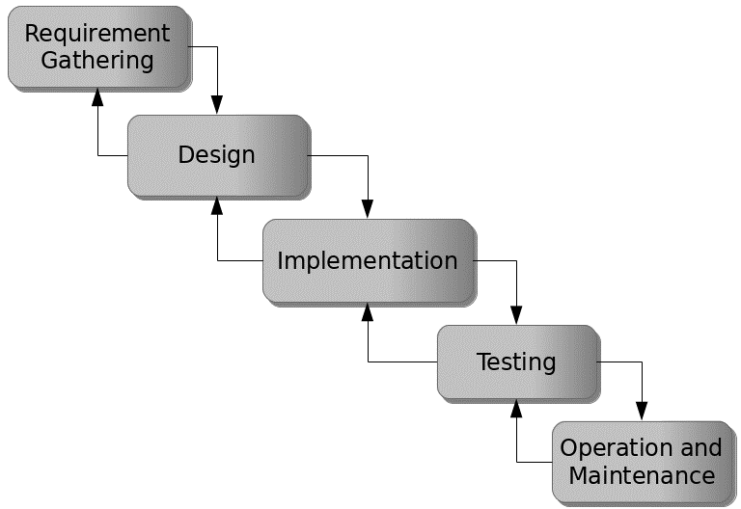

Figure 3.1: Waterfall model

## 3.5 Method of Data Collection

This study adopted two methods of data collection which are the primary and secondary method.

## 3.6 System Design

Systems design is the process of defining the architecture, modules, interfaces, and data for a system to satisfy specified requirements. Systems design could be seen as the application of systems theory to product development.

## 3.6.1 Algorithm Diagram

**Use Case Diagram**

A use case diagram at its simplest is a representation of a user’s interaction with the system and depicting the specifications of a use case.

Login

Add Employee

System settings

View/Edit/Delete

Admin

Apply for leave

Approve/Decline Leave

Print Report

Log out

User

Search

Figure 3.2: Use case diagram

## 3.6.2 System Architecture



Database MySQL

Apache Server

Database Management Model

Figure 3.2: System Architecture

## 3.6.3 Database Tables/Queries Structures

## Table 3.1: Employees Table

|  |  |  |  |  |
| --- | --- | --- | --- | --- |
| **Field** | **Datatype (length)** | **Null** | **Key** | **Extra** |
| id | int(10) | NO | PRIMARY | auto_increment |
| Employee_id | int(10) | YES |  |  |
| Firstname | varchar(50) | YES |  |  |
| Middlename | varchar(50) | YES |  |  |
| Lastname | varchar(50) |  |  |  |
| Email | varchar(50) |  |  |  |
| Date of Birth | varchar(50) |  |  |  |
| Gender | varchar(50) |  |  |  |
| Phone Number | varchar(50) |  |  |  |
| Address | varchar(50) |  |  |  |
| LGA | varchar(50) |  |  |  |
| State | varchar(50) |  |  |  |
| Country | varchar(50) |  |  |  |
| Marital Status | varchar(50) |  |  |  |
| Photograph | varchar(50) |  |  |  |
| Leave date | varchar(50) |  |  |  |
| Position | Varchar(50) |  |  |  |
| Date | timestamp |  |  |  |

#### Table 3.2: Admin Login Table

|  |  |  |  |
| --- | --- | --- | --- |
| **Field** | **Type** | **Key** | **Extra** |
| Id | int(10) | PRI | auto_increment |
| First name | varchar(50) |  |  |
| Lastname | varchar(50) |  |  |
| Username | varchar(50) |  |  |
| Password | varchar(50) |  |  |
| Photograph | varchar(50) |  |  |
| Date | timestamp |  |  |

## 3.6.4 Entity Relationship Diagram

This shows the relationship of the various tables in the database with each other

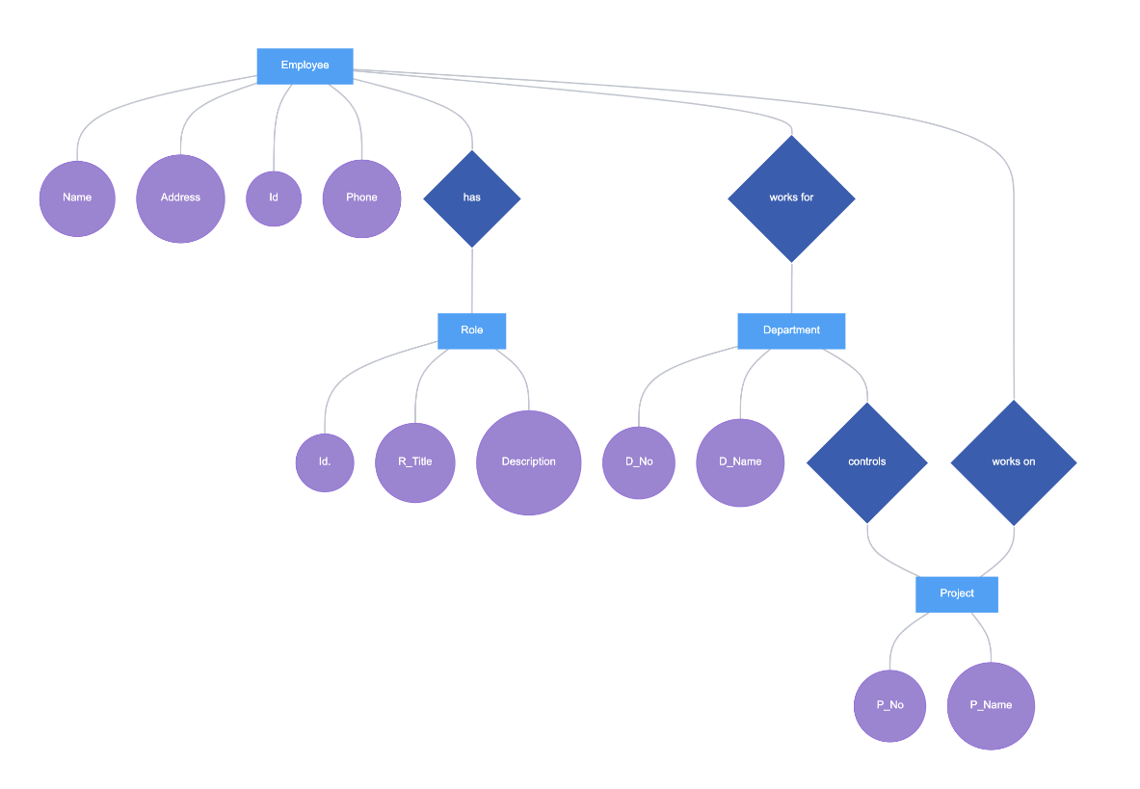

Figure 3.4: Entity Relationship Diagram

## 3.6.5 Input and Output Design

**LOGIN**

Enter Username

Enter Password

**Login**

Figure 3.5: Login interface

First name

Gender:

Address:

Country

**ADD EMPLOYEE**

Photograph

Marital Status

Phone Number

Role

Password

Join Date

Last Name:

State

Position

Employee ID

Othername:

Date of Birth:

LGA of Origin:

Email

**SUBMIT**

**CANCEL**

Figure 3.6: Add Employee Form

| **#** | **Photograph** | **Employee Name** | **Position** | **Full Details** |
| --- | --- | --- | --- | --- |
| 1 |  | VICTORIA MENKU | ACCOUNTANT | VIEW |
| 2 |  | IBRAHIM MUSA | ADMIN HR | VIEW |

Figure 3.7: Report Interface

## 3.7 System Requirements Specification

**3.7.1 Hardware Requirements**

The software designed needed the following hardware for an effective operation of the newly designed system.

1. A system running on intel, P(R) duo core with higher processor
2. The-Random Access Memory (RAM) should be at least 512mb.
3. Enhanced keyboard.
4. At least 20-GB hard disk.
5. V.G.A or a colored monitor.

## 3.7.2 Software Requirements

The software requirements include:

1. A window 7 or higher version of operating system.
2. XAMP or WAMP for Database
3. PHP

## 3.7.3 Personnel Requirements

Any computer literate who has a technical knowhow of internet surfing can use the system because it is user friendly.

# CHAPTER FOUR

# RESULTS AND DISCUSSION

## 4.1 Introduction

The new system is designed using PHP and MySQL programming language for easy records inserting and updating. This system will help in managing and easily retrieving of information from the system for management purposes. The new system Student with National Diploma for computer science department.

## 4.2 Results

## 4.2.1 Welcome Interface

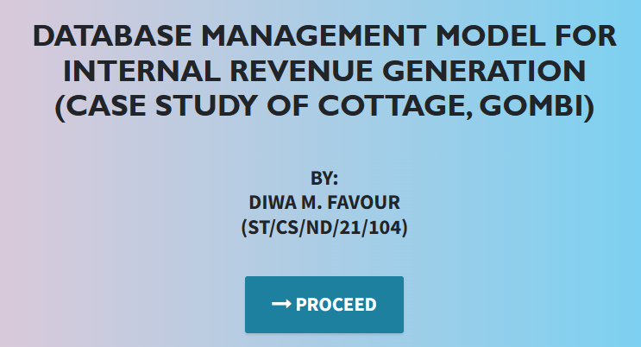

Figure 4.1: Welcome Interface

The above figure 4.1 shows the welcome page of the system, the welcome page is the first page that displays on opening the program.

## 4.2.2 Login Interface

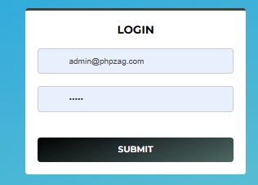

Figure 4.2: Login page interface

Figure 4.2 above shows the system login page interface. The login interface allows the users and Administrator to enter his username and password to get access to the system.

## 4.2.3 Add Employee Interface

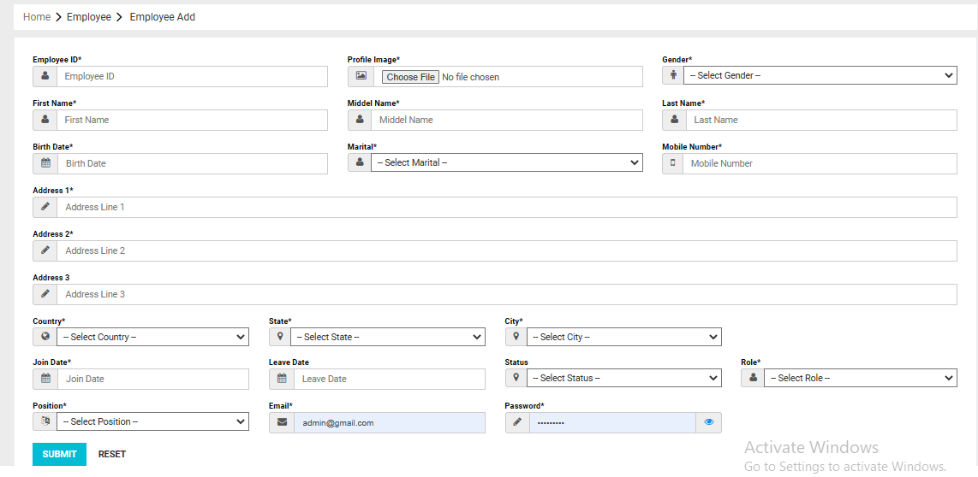

Figure 4.3: Add Employee Interface

Figure 4.3 above shows where employees are registered into the system for records of Internal revenue generation cottage.

## 4.2.4 Employees List interface

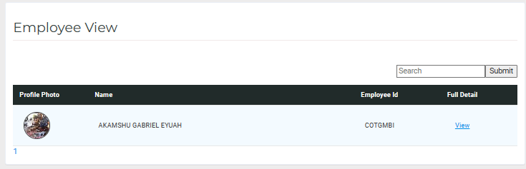

Figure 4.4: Employee List Interface

Figure 4.4 interface shows the employee list of all the registered employees in the system.

## 4.2.5 Dashboard Interface

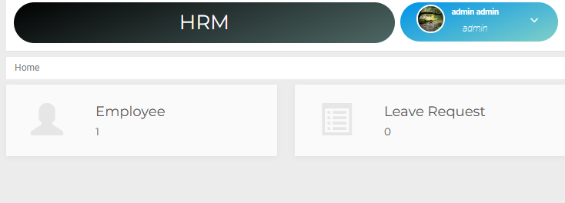

Figure 4.5: Dashboard Interface

Figure 4.5 above displays the admin dashboard showing all the tasks that can be performed in the system.

## 

## 4.3 Discussion

Figure 4.1 Welcome Interface: The Welcome Interface is the first screen users encounter when accessing the system. Its purpose is to provide a friendly and informative welcome message, possibly with the organization's logo or branding. This interface should create a positive first impression and guide users to navigate further into the system.

Figure 4.2 Login Interface: The Login Interface is where authorized users log in to access the database management system. Users typically enter their credentials (username and password) to gain access. Security measures such as encryption and multi-factor authentication might be implemented to protect sensitive tax-related data.

Figure 4.3 Add Employee Interface: The Add Employee Interface is used by administrators or authorized personnel to input employee information into the database. This information could include personal details, job roles, and access permissions. It's essential for maintaining an organized record of the staff responsible for revenue generation activities.

Figure 4.4 Employees List Interface: The Employees List Interface displays a comprehensive list of all employees within the organization. This interface might allow users to search, filter, or sort the employee list, making it easier to find specific personnel. It can also provide quick access to individual employee profiles.

Figure 4.5 Dashboard Interface: The Dashboard Interface is a central hub that offers an overview of key performance indicators and data related to internal revenue generation. It may include charts, graphs, and statistics to help management and users track revenue trends, tax collection, and other relevant metrics. A well-designed dashboard can facilitate data-driven decision-making.

These interfaces collectively contribute to efficient database management, allowing the organization to track and optimize its revenue generation efforts effectively. Additionally, they help ensure user-friendly interactions with the system, improving overall productivity and data accuracy.

## 4.4 User manual

The following are the necessary steps to take in order to use the system efficiently and effectively.

1. Load the url of the system <https://localhost/cottage/> the welcome page will be displayed.
2. Click on the **Proceed** button to proceed to the main system.
3. If you created an account, provide your login details by entering your username and password.
4. Depending on the login details provided you will be automatically directed to the dashboard.
5. The various task that you can perform on the portal will be displayed on the sidebar of the dashboard.

# CHAPTER FIVE

# SUMMARY, CONCLUSION AND RECOMMENDATIONS

## 5.1 Summary

The Database Management Model for Internal Revenue Generation discussed in this study represents a critical tool for modern organizations, particularly in the context of revenue collection. The system comprises a set of well-defined interfaces, including a welcoming interface, login interface, employee management interface, employee list interface, and a comprehensive dashboard. These interfaces collectively facilitate efficient data management, allowing organizations to track and optimize their revenue generation efforts. By implementing this model, organizations can enhance their ability to collect, manage, and analyze revenue data, leading to improved financial performance.

## 5.2 Conclusion

In conclusion, the development and implementation of a robust Database Management Model for Internal Revenue Generation are pivotal for the success of contemporary organizations. This model, with its user-friendly interfaces and data-driven dashboard, empowers organizations to streamline revenue collection, monitor financial performance, and make informed decisions. Properly managing internal revenue is essential for sustaining and growing any enterprise, and this model provides a solid foundation for achieving this goal.

## 5.3 Recommendations

Based on our findings, we offer the following recommendations:

1. Organizations should consider implementing this database management model or similar systems to enhance their internal revenue management.
2. Regular training and updates should be provided to employees to ensure effective utilization of the system.
3. Continuous monitoring and security measures should be in place to safeguard sensitive revenue-related data.
4. Organizations should explore integration options with existing financial systems for seamless data flow.

## 5.4 Contribution to Knowledge

This study contributes to knowledge by presenting a practical model for internal revenue management. It outlines the importance of database management systems in revenue collection and highlights the significance of user-friendly interfaces and data visualization through dashboards. Additionally, it underscores the need for integrating technology into financial processes for efficiency and accuracy.

## 5.5 Area for Further Work

There are several avenues for further research in this domain:

Investigating the impact of this database management model on revenue generation in various organizational contexts.

Exploring advanced data analytics and machine learning techniques to improve revenue forecasting and fraud detection.

Assessing the scalability and adaptability of the model for different industries and organizations of varying sizes.

Examining the security measures and compliance requirements associated with revenue management systems in different regions or industries.

# REFERENCES

Adams, K. (2022). The Role of Automation in Educational Financial Management. *Journal of Information Technology in Education,* 15(3), 120-135.

Aguinis, K., & Kraiger, J. (2022). The Impact of Payment Systems on Error Reduction in Educational Institutions. *International Journal of Educational Finance,* 20(1), 56-70.

Allen, D. & James, M. (2021). Retaining Talent: The Relationship between Rewards, Engagement, and Turnover. *Journal of Management,* 46(8), 1300-1328.

Allen, D. G., Bryant, P. C., & Vardaman, J. M. (2021). Retaining Talent: The Relationship between Rewards, Engagement, and Turnover. *Journal of Management,* 46(8), 1300-1328.

Anderson, L., & Schalk, S. (2018). Ensuring Data Security in Payment Systems for Educational Institutions. *International Journal of Cybersecurity*, 18(1), 45-60.

Armstrong, M. (2019). *Armstrong's Handbook of Human Resource Management Practice*. Kogan Page Publishers.

Bendl, Y. (2021). Application of Predictive Modeling in Education: A Review. *Journal of Computers in Education,* 8(1), 19-37.

Cable, S. M., & Judge, A. (2016). Success Factors and Barriers of Adopting the Automated System of Student Affairs in Saudi Universities. *International Journal of Higher Education,* 8(3), 1-9.

Denisi, U. & Kluger, W. (2020). Mobile Property Management Systems: A Study of Design and Implementation. *Information Systems Frontiers*, 1-14.

Elmasri, R., & Navathe, S. B. (2019). *Fundamentals of Database Systems.* Pearson, New York.

Ghazal, O., Ionita, H. & Gorges, O. (2020). An Artificial Intelligence Platform for Property Management: *A Conceptual Model. Computers in Industry*, 125, 103-379.

Goblar, N. (2022). Decision Support System in Higher Education: A Case Study of an Adaptive Learning Management System. *Journal of Computers in Education,* 8(2), 215-239.

Illmakunnas, H. (2023). Adoption of E-payment Systems in Higher Education: A Comparative Study*. International Journal of Educational Technology*, 14(3), 57-72.

Jagero, R., & Kangethe, A. (2020). The Importance of Financial Transparency in Educational Institutions. *Journal of Education Finance and Policy,* 25(2), 89-104.

Jurban, L., Turner, R., & Gonzalez, E. (2023). Improving Financial Management in Universities with Payment Systems. *Journal of Higher Education Management,* 16(2), 78-92.

Kalesh, S. & Tuwei, J. (2022). Web-based Rental Property Management System for Efficient and Effective Property Management. *Journal of Engineering Technology*, 18(1), 221-229.

Kapoor, A., & Singh, P. (2020). Digital Transformation in Compensation and Benefits Management. *International Journal of Recent Technology and Engineering*, 9(2), 6742-6746.

Lazear, S., & Rosen, M. (2023). Student Perspectives on Payment Systems in Higher Education. *International Journal of Educational Technology*, 15(1), 34-48.

Liu, K., Letchkov, N., Koychev, I., & Ivanov, B. (2020). Cloud-Based Property Management Systems. *In Proceedings of the International Conference on Advances in Business, Management and Law*, 7(1), 169-177.

Mahmud, N. (2020). Evaluation of Records Management Systems in Public Universities in Kenya. *International Journal of Information Systems and Project Management,* 8(3), 43-62.

Martins, A., Proença, T., & Gonçalves, R. (2020). Employee Compensation, Incentives, and Innovation. *Research in Human Resource Management (RHRM),* 12(1), 45-54.

Mathe, U., Lee, L., Ming, I., & Hashim, L. (2021). The Role of Management Information Systems in Data Analytics: A Strategic Perspective on Global Business Environments. *Information Systems Frontiers,* 22(4), 909-924.

Motahari-Nezhad, H. R., Stephenson, B., Shahbazian, M., & Foster, H. (2021). Database Management Systems. *In Handbook on Securing Cyber-Physical Critical Infrastructure* (pp. 195-217). Springer.

Olivera, M. & Martins, L. (2021). The Adoption of Property Management Systems in the Real Estate Sector. *Journal of Business and Management*, 23(2), 71-92.

Poon, J. M. (2019). The Impact of Non-Financial Rewards on Employee Engagement and Retention. *Employee Relations*, 41(2), 333-348.

Rahman, L., Huang, O., Tim, R. & Gehrke, J. (2020). *Database Management Systems*. McGraw-Hill.

Ramakrishnan, M. & Gehrke, M. (2020). An Integrated Framework for E-Records Management System (ERMS) Development: A Study on Bangladesh Government Sector. *International Journal of Electronic Government Research*, 16(3), 19-38.

Reddy, B. S., & Kumar, G. P. (2021). Personalized Compensation and Benefits: A New Paradigm. *International Journal of Applied Engineering Research*, 16(1), 69-73.

Rizvi, S., Khan, M. A., Bhatti, R. A., & Ziauddin, Z. (2021). A Comparative Study of Database Management Systems. *Journal of Information Systems and Technology Management*, 18, 202-1134.

Shore, F. (2019). A Model for Developing a Student Management System (SMS) in Saudi Universities. *Journal of Educational Computing Research,* 58(3), 523-552.

Singhal, J. (2021). Digital Transformation in Higher Education: Advancements and Challenges. *International Journal of Educational Technology,* 12(4), 65-79.

Tziner, J. & Vardi, K. (2018). Cloud-Based Property Management System with Mobile Integration for Small and Medium-Sized Landlords. *Journal of Systems and Information Technology*, 23(3), 486-503.

Vroom Q. (2017). A Framework for Smart Rental Property Management. *IEEE Access*, 8, 134127-134139.

Wasana, A. (2020). Design and Development of Mobile Applications for Property Management. *International Journal of Information Systems and Project Management,* 9(2), 5-19.

Wayne, K. (2022). Digitalizing Student Fee Management: Challenges and Opportunities. *Journal of Educational Administration,* 46(1), 89-105.

Welch, M., & Jackson, S. E. (2017). Rethinking Diversity in Research on Organizations: Toward a Structural Perspective. *Research in Organizational Behavior*, 27, 3-30.

Wu, L., & Zhu, C. (2021). Security Considerations in Designing University Payment Systems. *Journal of Information Security,* 35(2), 213-228.

# APPENDIX A

## Welcome Interface



## Login Interface



## Add Employee Interface



## Employees List interface



## Dashboard Interface



# APPENDIX B

**PROGRAM CODE**

<!DOCTYPE html>

<html lang="en">

  <head>

    <meta charset="utf-8">

    <meta name="viewport" content="width=device-width, initial-scale=1, shrink-to-fit=no">

    <meta name="description" content="">

    <meta name="author" content="">

    <title>NATIONAL DIPLOMA</title>

    <!-- Bootstrap Core CSS -->

    <link href="vendor/bootstrap/css/bootstrap.min.css" rel="stylesheet">

    <!-- Custom Fonts -->

    <link href="vendor/font-awesome/css/font-awesome.min.css" rel="stylesheet" type="text/css">

    <link href="https://fonts.googleapis.com/css?family=Source+Sans+Pro:300,400,700,300italic,400italic,700italic" rel="stylesheet" type="text/css">

    <link href="vendor/simple-line-icons/css/simple-line-icons.css" rel="stylesheet">

    <!-- Custom CSS -->

    <link href="css/stylish-portfolio.min.css" rel="stylesheet">

  </head>

  <body id="page-top" style=" background: linear-gradient(90deg, pink, rgb(67, 207, 250));">

    <!-- Header -->

    <header class="masthead d-flex">

      <div class="container text-center">

        <h1 class="mb-2" style="font-size: 45px; font-weight: bolder; font-family: 'Gill Sans', 'Gill Sans MT', Calibri, 'Trebuchet MS', sans-serif; text-transform: uppercase;"><span style=" margin-top:15px;"> DESIGN AND IMPLEMENTATION OF AN Automated Information System (AIS) for students with National Diploma</span> <br>  </h1>

        <h2 class="mb-3" style="">(A case study of COMPUTER SCIENCE DEPARTMENT)</h2><br><br>

        <h2>BY: <br> BITRUS USA <br> (ST/CS/ND/21/011)</h2> <br>

        </h3>

        <br>

        <strong><a class="btn btn-primary btn-xl js-scroll-trigger" href="grading/login.php" style="font-size: 30px;"><span class="fa fa-long-arrow-right"></span> PROCEED</a></strong>

        <br> <br> <br>

        <!-- <h4 class="alert alert-success"><a href="onlinefood-order/admin/index.php">Admin Login Here!</a></h4> -->

              </div>

      <div class="overlay"></div>

    </header>

    <!-- Scroll to Top Button-->

    <a class="scroll-to-top rounded js-scroll-trigger" href="#page-top">

      <i class="fa fa-angle-up"></i>

    </a>

    <!-- Bootstrap core JavaScript -->

    <script src="vendor/jquery/jquery.min.js"></script>

    <script src="vendor/bootstrap/js/bootstrap.bundle.min.js"></script>

    <!-- Plugin JavaScript -->

    <script src="vendor/jquery-easing/jquery.easing.min.js"></script>

</html>

<h1>Welcome to <?php echo $_settings->info('name') ?></h1>

<hr class="bg-light">

<?php if($_settings->userdata('type') != 3): ?>

<div class="row">

          <div class="col-12 col-sm-6 col-md-3">

            <div class="info-box">

              <span class="info-box-icon bg-light elevation-1"><i class="fas fa-file-alt"></i></span>

              <div class="info-box-content">

                <span class="info-box-text">Pending Applications</span>

                <span class="info-box-number text-right">

                  <?php

                    $pending = $conn->query("SELECT * FROM `leave_applications` where date_format(date_start,'%Y') = '".date('Y')."' and date_format(date_end,'%Y') = '".date('Y')."' and status = 0 ")->num_rows;

                    echo number_format($pend            </div>

            <!-- /.info-box -->

          </div>

          <!-- /.col -->

          <div class="col-12 col-sm-6 col-md-3">

            <div class="info-box mb-3">

              <span class="info-box-icon bg-info elevation-1"><i class="fas fa-building"></i></span>

              <div class="info-box-content">

                <span class="info-box-text"> Departments</span>

                <span class="info-box-number text-right">

                  <?php

                    $department = $conn->query("SELECT id FROM `department_list` ")->num_rows;

                    echo number_format($department);

                  ?>

                </span>

              </div>

              <!-- /.info-box-content -->

            </div>

            <!-- /.info-box -->

          </div>

          <!-- /.col -->

          <!-- fix for small devices only -->

          <div class="clearfix hidden-md-up"></div>

          <div class="col-12 col-sm-6 col-md-3">

            <div class="info-box mb-3">

              <span class="info-box-icon bg-lightblue elevation-1"><i class="fas fa-th-list"></i></span>

              <div class="info-box-content">

                <span class="info-box-text"> Designations</span>

                <span class="info-box-number text-right">

                <?php

                    $designation = $conn->query("SELECT id FROM `designation_list`")->num_rows;

                    echo number_format($designation);

                  ?>

                </span>

              </div>

              <!-- /.info-box-content -->

            </div>

            <!-- /.info-box -->

          </div>

          <div class="col-12 col-sm-6 col-md-3">

            <div class="info-box mb-3">

              <span class="info-box-icon bg-purple elevation-1"><i class="fas fa-list"></i></span>

              <div class="info-box-content">

                <span class="info-box-text">Promotion Types</span>

                <span class="info-box-number text-right">

                <?php

                    $leave_types = $conn->query("SELECT id FROM `leave_types` where status = 1 ")->num_rows;

                    echo number_format($leave_types);

                  ?>

                </span>

              </div>

              <!-- /.info-box-content -->

            </div>

            <!-- /.info-box -->

          </div>

        </div>

<?php else: ?>

  <div class="row">

    <div class="col-12 col-sm-6 col-md-3">

      <div class="info-box">

        <span class="info-box-icon bg-light elevation-1"><i class="fas fa-file-alt"></i></span>

        <div class="info-box-content">

          <span class="info-box-text">Pending Applications</span>

          <span class="info-box-number text-right">

            <?php

              $pending = $conn->query("SELECT * FROM `leave_applications` where date_format(date_start,'%Y') = '".date('Y')."' and date_format(date_end,'%Y') = '".date('Y')."' and status = 0 and user_id = '{$_settings->userdata('id')}' ")->num_rows;

              echo number_format($pending);

            ?>

            <?php ?>

          </span>

        </div>

        <!-- /.info-box-content -->

      </div>

      <!-- /.info-box -->

    </div>

    <div class="col-12 col-sm-6 col-md-3">

      <div class="info-box">

        <span class="info-box-icon bg-lightblue elevation-1"><i class="fas fa-th-list"></i></span>

        <div class="info-box-content">

          <span class="info-box-text">Promotion Requests</span>

          <span class="info-box-number text-right">

            <?php

              $upcoming = $conn->query("SELECT * FROM `leave_applications` where date(date_start) > '".date('Y-m-d')."' and status = 1 and user_id = '{$_settings->userdata('id')}' ")->num_rows;

              echo number_format($upcoming);

            ?>

            <?php ?>

          </span>

        </div>

        <!-- /.info-box-content -->

      </div>

      <!-- /.info-box -->

    </div>

  </div>

<?php endif; ?>